Part Number: PT948-47161-02

Kit Contents
Item # | Quantity Reqd. | Description
1 | 1 | Shifter Bezel Applique
2
3
Hardware Bag Contents
Item # | Quantity Reqd. | Description
1
2
3
Additional Items Required For Installation
Item # | Quantity Reqd. | Description
1
2
3
Conflicts
None
Recommended Tools
Personal & Vehicle Protection | Notes
Special Tools | Notes
Surface Thermometer | Infrared Non-contact
Heat Gun | Master Heat Gun HG-301A or equivalent
Installation Tools | Notes
Lint-free scratch resistant cloth
Special Chemicals | Notes
Cleaner | VDC Approved cleaner
General Applicability
All 2016 and newer Toyota Prius
Recommended Sequence of Application
Item # | Accessory
1 | Shifter Bezel Applique
*Mandatory
Vehicle Service Parts (may be required for reassembly)
Item # | Quantity Reqd. | Description
1
2
3
Legend
STOP: Damage to the vehicle may occur. Do not proceed until process has been complied with.
OPERATOR SAFETY: Use caution to avoid risk of injury.
CAUTION: A process that must be carefully observed in order to reduce the risk of damage to the accessory/vehicle and to ensure a quality installation.
TOOLS & EQUIPMENT: Used in Figures calls out the specific tools and equipment recommended for this process.
REVISION MARK: This mark highlights a change in installation with respect to previous issue.
SAFETY TORQUE: This mark indicates that torque is related to safety.

Care must be taken when installing this accessory to ensure damage does not occur to the vehicle. The installation of this accessory should follow approved guidelines to ensure a quality installation.

These guidelines can be found in the "Accessory Installation Practices" document.

This document covers such items as:-
- Vehicle Protection (use of covers and blankets, cleaning chemicals, etc.).
- Safety (eye protection, rechecking torque procedure, etc.).
- Vehicle Disassembly/Reassembly (panel removal, part storage, etc.).
- Electrical Component Disassembly/Reassembly (battery disconnection, connector removal, etc.).

Please see your Toyota dealer for a copy of this document.

- Prepare for the Installation.
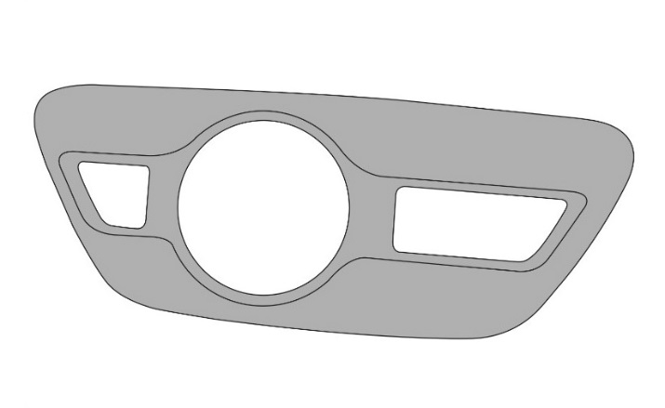
  - Inspect the kit for contents and damage (Fig. 1-1).
Fig. 1-1
  - Thoroughly clean all installation surfaces.
    - Always use a clean lint-free scratch resistant cloth.
    - Shake the VDC approved cleaner well.

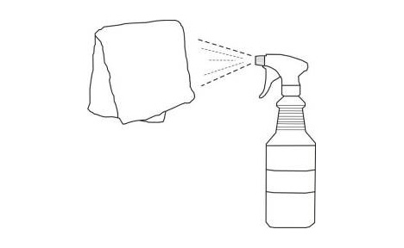
  - Apply VDC approved cleaner directly to the cloth. Do not spray cleaning solutions directly onto the vehicle (Fig.1-2).
Fig. 1-2
Lint-free cloth

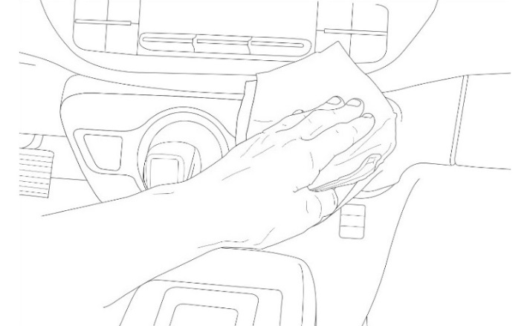
  - Clean the surface thoroughly and wipe dry immediately with a clean cloth (Fig. 1-3). Do not allow the cleaner to air dry.
Fig. 1-3
  - Apply water to a clean cloth. Clean the surface thoroughly to ensure any VDC approved cleaner is completely removed. Wipe dry with a clean cloth.

  - The vehicle installation surface and applique must be between 70°F (21°C) and 110°F (43°C) at the time of installation.
NOTE: A heat source may be used to reach minimum temperature if necessary.

Install the Part.
  - Before removing any adhesive liner on the back of the part, align the part and confirm that the fit is correct.
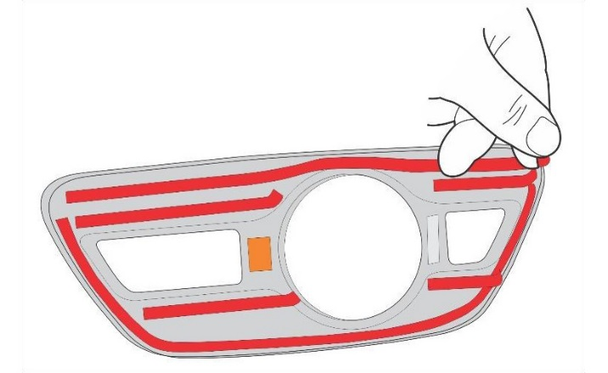
  - Remove the 4 inner adhesive liners on the back of the part (A, Fig. 2-1).
Fig. 2-1
A
A
A
A
B
B
NOTE: Be sure not to touch any of the adhesive backing.

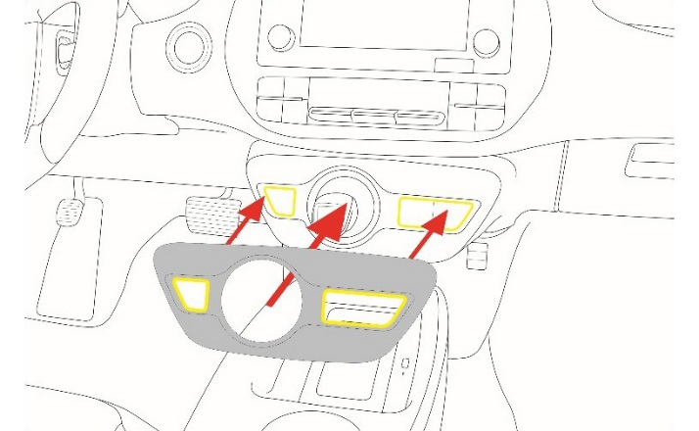
  - Position the factory shift knob through the center hole of the applique and align the applique uniformly to the edges of the factory part. Confirm that both outer holes of the applique (highlighted in yellow) are completely aligned (Fig. 2-2).
Fig. 2-2
  - Gently touch the applique into position.
  - Peel the 2 outer adhesive liners (B, Fig. 2-1).

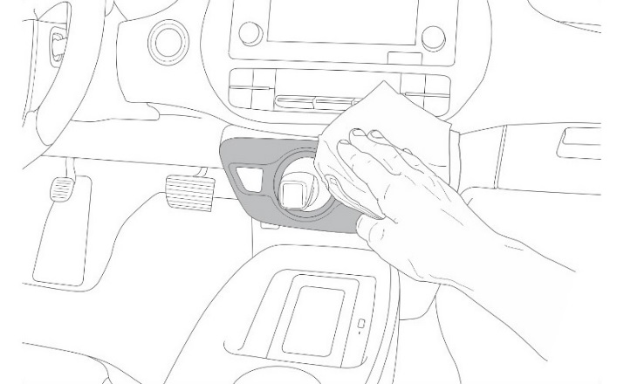
  - Use a clean, dry cloth and firmly press the applique against the factory part in all areas to ensure the adhesive makes contact (Fig 2-3).
Fig. 2-3
  - Confirm that the edges of the applique are flush to the edges of the factory part and all interior holes are centered.

Accessory Function Checks
Shifter bezel applique – Adhesive

Shifter bezel applique - Alignment

Vehicle Function Checks
Button operation

Applique should be securely adhered to the factory part.

Edges of applique should be flush to edges of factory part, +/- 2mm and interior spacing between applique and factory part should be uniform.

Applique should not interfere with the movement of any buttons.

Vehicle Appearance Check
After accessory installation, perform a visual inspection.

Ensure no damage (including scuffs and scratches) was caused during the installation process.
(For PPO installations, refer to TMS Accessory Quality Shipping Standard.)

